# Adobe Photoshop Effects

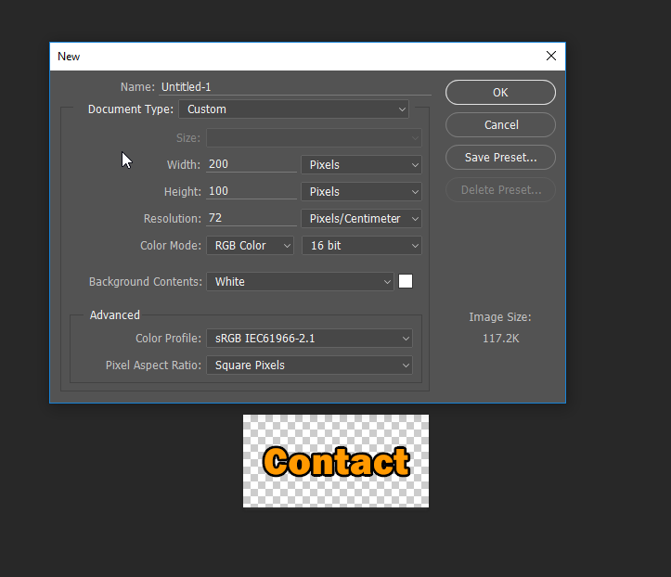

* Each button started as a blank Photoshop document at 200 Pixels by 100 Pixels
* They were later all cropped to 128 Pixels by 33 Pixels to fit the website

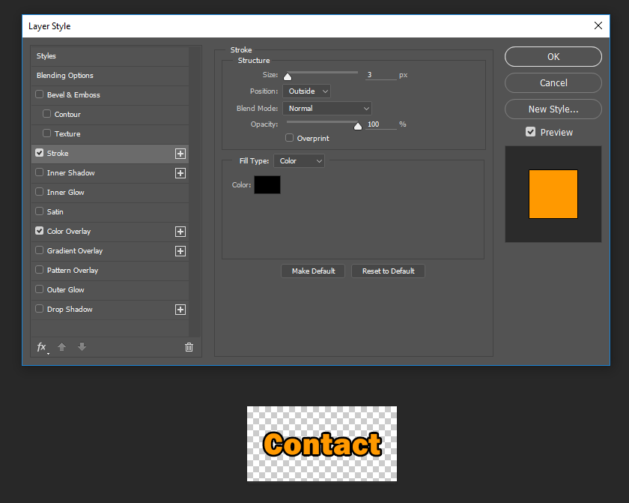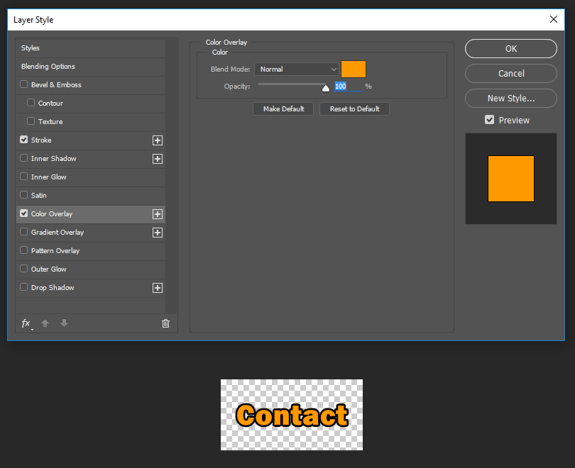

* The two effects used on the buttons were a stroke and colour overlay effect
* For the “Hover” effect on the buttons when hovered over with a computer mouse pointer, the colours used for these effects were flipped: Normally Colour overlay is orange, and stroke is black. On mouse hover, these flip.
  + It should be noted, that the hover effect was never implemented in the final version of the website due to time constraints, however the files are ready to be used
* The font chosen was Franklin Gothic Heavy Regular; it was chosen due to its ease of readability while looking modern at the same time; it also matched the overall theme of the website.